In the Boolean model the results are not ranked. Documents either contain the word or do not.

Ranked retrieval

* It is important to rank search results in terms of relevance. Users only look at the 10 top results at most.
* Can rank the documents using a score.
* How can you measure the relevance?
* An idea: Rank based on how many times query terms appear in the document.
* Problems: Document lengths vary, so in larger documents query terms may occur more frequently than in smaller documents.
* And: Rare terms are more informative than frequent terms. E.g Biology appearing once in a document may have more relevance than the term ‘the’ appearing 10 times.

Zipf’s law

* Frequency of any word in a given collection is inversely proportional to its rank in the frequency table.
* r * frequency ≈ constant
* 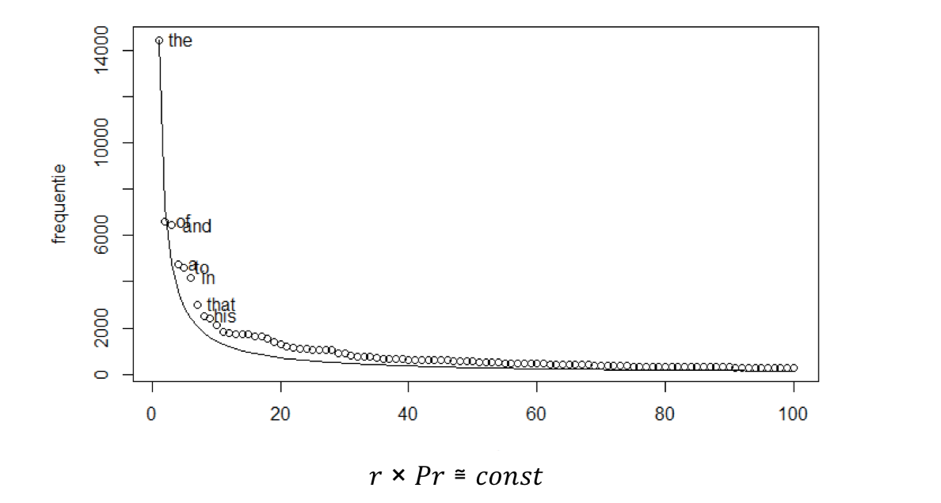For example the 2nd ranked will appear about half as often as the first most often term. The 3rd ranked will appear about as 3rd as often as the most frequent term and so on. Term occurrence is proportional to (occurrence of most frequently used word) * **1/rank**.

Question: But what is this trying to say?

* [Zipf's Law YT vid](https://www.youtube.com/watch?v=fCn8zs912OE)

Luhn’s hypothesis

* 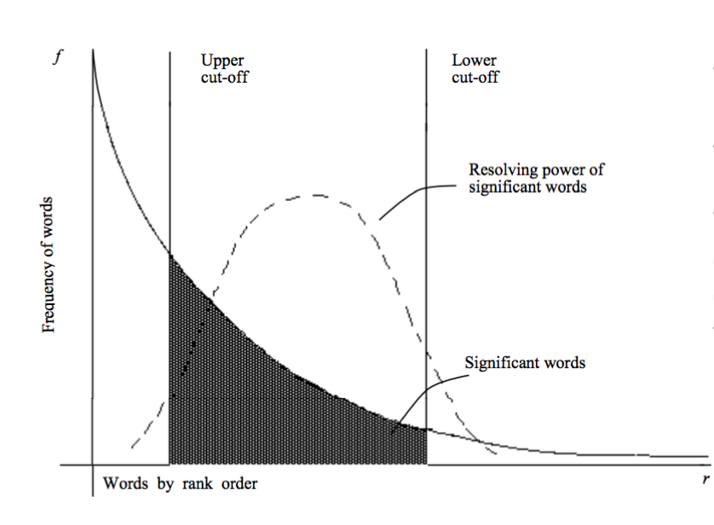The words exceeding the upper cut off are considered to be common
* The words below the lower cut-off are considered rare, and therefore do not contribute significantly to the content of the article.

Term Frequency (tf)

* tf*t,d,* The **number of times the term occurs in the document.**
* Do not want **raw term frequency.**
* **Raw term frequency** is when the number of occurrences of a term is related to the relevance to the query. And all terms are considered of equal importance.
* **Relevance does not increase proportionally with term frequency.**

Document frequency (df)

* In **how many documents** term appears
* If rare, the term occurs in fewer documents.
* Rare terms **more informative** than frequent terms, so should have higher positive weights.

Inverse document frequency (idf)



* The larger the ratio of N/dft is large then the more rare the term is.
* Log of the ratio is computed to make the number smaller and more comparable.

Collection vs document frequency

* Collection frequency is the number of times a term occurs in a **collection.**
* But this does not tell us how rare the term is in terms of how many documents is appears in.
* A term which occurs a similar number of times in a collection could have a higher document frequency.
* So collection frequency is not an indicator of how rare a term is or is not because it gives no details about how many documents the term has appeared in.



Tf.idf weighting

The tf-idf weight of a term is the product of its tf weight and its idf weight.

* This gives the weighting of the terms in a document based on its idf and tf.
* The **more rar**e the term (idf) then the **greater the weighting**
* The **greater the occurrence of the term** the greater in the document the **greater the weighting.**

Document ranking for a query

* For each document d, find the sum over all tf.idf weights of each query term t found in d.
* Output is a rank of documents according to score (q, d)

What to index?

* Can index individual words (unigrams, N=1) or multiple words (N-grams)

Term-document count matrix

* Gives the number of times a term appears in a document.

Weight matrix

* Gives the tf-idf of each term in a document.

Documents as vectors

* Terms are dimensions
* Documents are vectors in this space
* **Documents are represented as weighted tf.idf vector**
* Most entries are zero.



Queries as vectors

* Rank the queries as vectors in space
* Rank documents according to their **proximity to the query.**
* **Proximity is the distance between the vectors**
* Can measure distance in 2 ways: **distance between the endpoints of the two vectors (Euclidean Distance)** and **angle between the document and the query (Cosine of the angle).**



Cosine distance

* Need to normalize for length to ensure fair comparison.